**CSIS 2260 - Lab #4**

20

***Introduction to Virtual Machine***

Due date: 20:59 Feb 5, 2021 (Pacific Time)

**Name: Stephen Joy Student No.: 300329148 Section: 012**

**Insert the required screenshots in the Word file. Do not submit the screenshots separately.**

**Use a different font color for your answers.**

**Objectives:**

In this lab, you will compare the resources usage and performance differences between a virtual machine or VM (***guest*** ***system***) and the host computer (***host system***). You learn how to adjust the resources assigned to a virtual machine. The host computer is your own Windows 10 PC.

Note: While doing this lab, you should close all unnecessary applications on your PC. You can keep Word and VirtualBox running.

Download the Ubuntu 18.04.5 LTS Desktop image from <https://releases.ubuntu.com/18.04/>

(64-bit PC (AMD64) desktop image).

1. **Performance Comparison between the Guest System and the Host System [_____/10]**
2. Open Oracle VM VirtualBox Manager and start the Windows 10 virtual machine.
3. Disk size: For both the Windows 10 VM (Guest) and the Windows 10 (Host), do the following: click ***Start*** > ***Windows*** ***Administrative*** ***Tools*** > ***Computer*** ***Management***. Select ***Disk*** ***Management***. What is the disk size of each machine?

Windows 10 (Guest): **50.00 GB**

Windows 10 (Host): **476.92 GB**

Take a screenshot of the ***Disk Management*** window of each system and insert the screenshots in the space below.

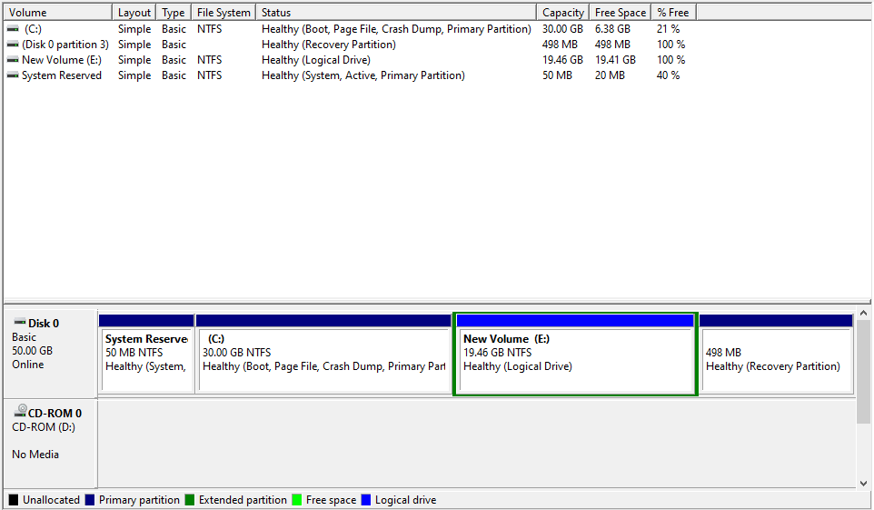

Guest OS

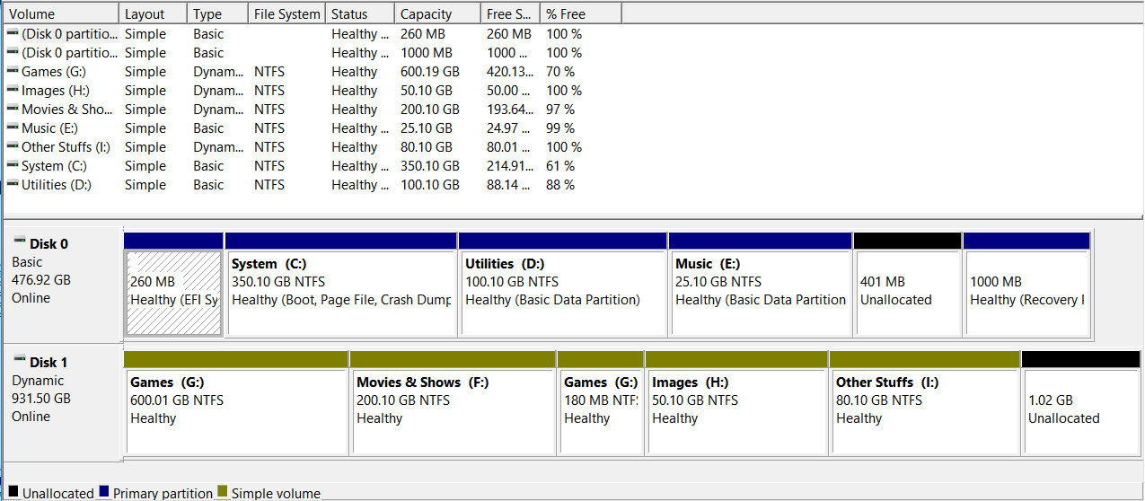

Host OS

Note: if you have more than one hard disk installed on your own computer, find out the disk used to install the Windows 10 OS and give the size of the disk (**NOT** the size of the partition).

1. System Performance: For both Windows 10 VM (Guest) and Windows 10 (Host), do the following: click ***Start*** > ***Windows*** ***System*** > ***Task*** ***Manager***. You may click *More details* for more information.
2. Under the ***Processes*** tab, what are the application(s) running?

Windows 10 (Guest): **Task Manager**

Windows 10 (Host): **Microsoft Word, Task Manager, VirtualBox Virtual Machine**

1. How many background processes are running?

Windows 10 (Guest): **25**

Windows 10 (Host): **196**

1. Under the ***Performance*** tab, what is the CPU utilization?

Windows 10 (Guest): **2%**

Windows 10 (Host): **13%**

1. What is the total memory size and its usage (in %)?

Windows 10 (Guest): **2.0 GB (55%)**

Windows 10 (Host): **15.9 GB (51%)**

Take a screenshot of the ***Performance*** tab of each system and insert the screenshots in the space below.

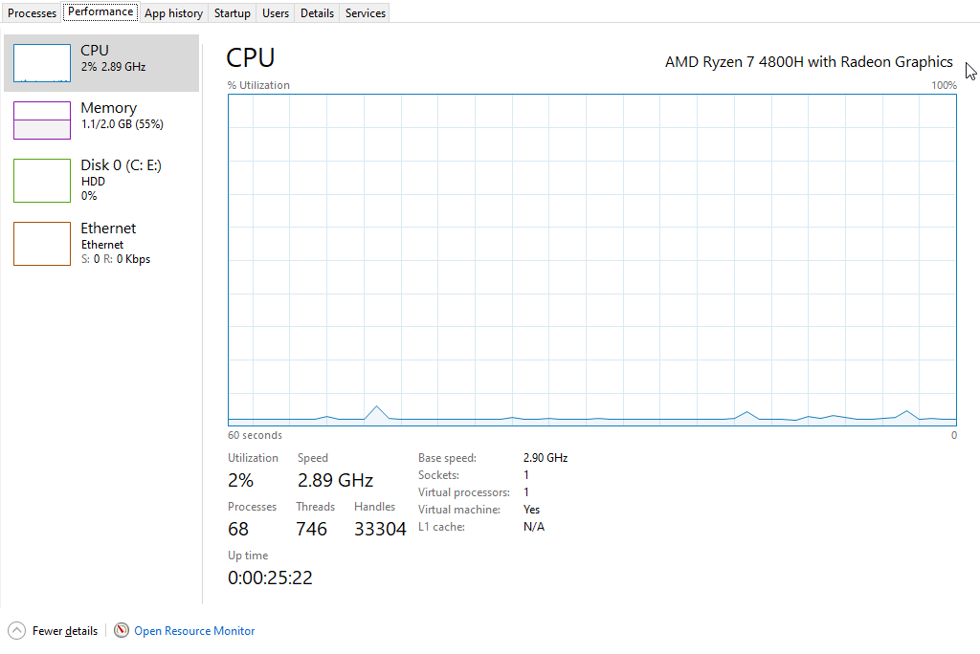

Guest OS

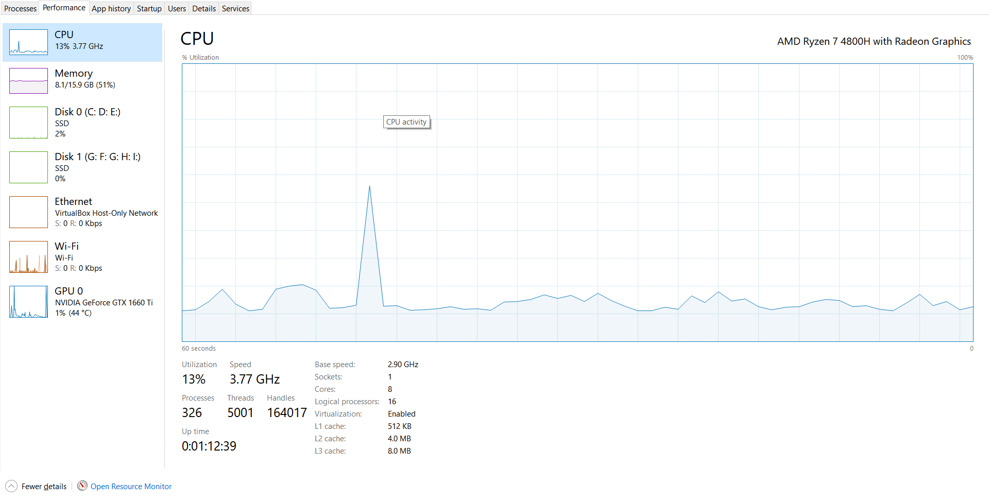

Host OS

1. Shut down the Windows 10 virtual machine. From the ***Task*** ***Manager*** in Windows 10 (Host), what is the memory usage (%) now? **36%**

In the following, you will install an Ubuntu virtual machine, which takes 10 GB disk space. If you do not have enough disk space available on your PC, you may remove the Windows 10 virtual machine and select Delete all files. This will delete the windows 10 VM and free up the disk space.

1. **Installation of Ubuntu Virtual Machine [_____/10]**
2. Go back to Oracle VM VirtualBox Manager. Click ***New*** to create a new virtual machine for Ubuntu (64-bit). You can name the virtual machine as ***Ubuntu***. Change the memory size to 2048 MB and take the default settings for other options when creating the VM.
3. Choose the ***Ubuntu*** virtual machine just created and click ***Start*** to power on it.
4. When prompt to select start-up disk, click the folder icon on the right. Click ***Add*** to select the downloaded Ubuntu ISO file and click ***Choose***. Click ***Start*** to begin system installation.
5. Wait for a while to start the Ubuntu installation process.
6. Select ***English*** and ***Install Ubuntu***.
7. Select ***Normal******Installation***, and ***Erase disk and install Ubuntu***. Note: this operation only erases the Ubuntu virtual disk and does not affect other operating systems.
8. Use your first name as the username and ***csis2260*** as the password for your account. Wait for the installation to complete. Note: the numeric keypad is turned off by default in Ubuntu.
9. Once the Ubuntu system is installed, you need to restart it and log in using your username and password (Press ***enter*** if you see the message “*Please remove the installation medium, then press ENTER*”). Skip all the Ubuntu introductory pages if appear.
10. Compare Ubuntu (Guest OS) and Windows 10 (Host OS) system resources usage.
11. On Ubuntu, click ***Show******Applications*** at the lower left. Look for the app ***System******Monitor*** and open it (you may type to search). Click the ***Resources*** tab on top.
12. On Windows 10, click ***Start*** > ***Windows******System*** > ***Task******Manager***.
13. Compare the CPU and memory usage and fill in the blanks in the table below.

|  |  |  |  |
| --- | --- | --- | --- |
|  | CPU usage (%) | Total memory | Memory usage (%) |
| Ubuntu | **9%** | **1.9 GB** | **54%** |
| Windows 10 | **5%** | **15.9 GB** | **49%** |

Take a screenshot of the ***Resources*** tab on Ubuntu and insert screenshot in the space below.

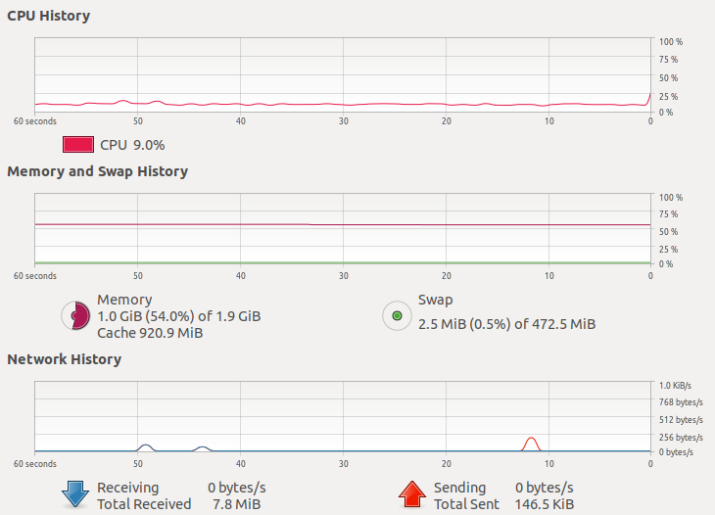

1. Power off the Ubuntu virtual machine (DON’T save the machine state). From the ***Task******Manager*** in Windows 10 (Host OS), what is the memory usage (%) now? **35%**
2. Select the Ubuntu VM in Oracle VM VirtualBox Manager and click ***Settings***.
3. To change the amount of main memory assigned to the Ubuntu VM: From ***System*** > ***Motherboard***, change the ***Base******Memory*** to 1800 MB.
4. Select the ***Processor*** tab and change the number of CPUs assigned to the Ubuntu VM to 2. Click ***OK*** to apply the change.
5. Start the Ubuntu virtual machine, click ***Show******Applications*** at the lower left, open ***System*** ***Monitor***, and click the ***Resources*** tab on top. Now you will see two CPUs, CPU1 and CPU2. The total memory also changes. Take a screenshot of the ***Resources*** tab on Ubuntu and insert screenshot in the space below.

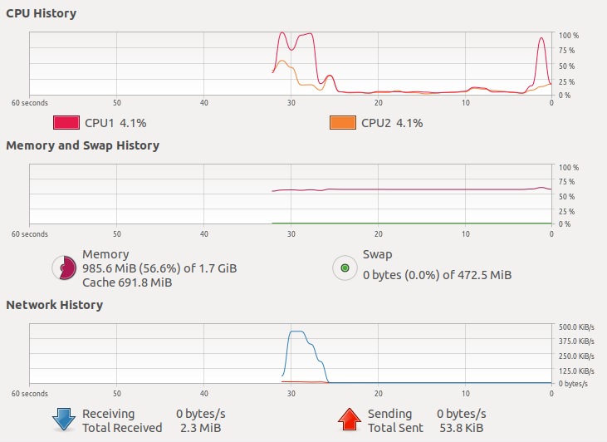

1. **Shutdown the Virtual Machine**
2. Power off the Ubuntu virtual machine.
3. Close Oracle VM VirtualBox Manager.

**Submission**

1. Save your lab file as YourFirstname_yourID_Lab4.docx.
2. Submit the Word file through Blackboard before the due (do not send labs by email please. Any lab submitted by email will be ignored). Late submissions will not be marked, and the student will lose the mark of that lab.
3. You may submit your work multiple times, but only the LAST submission before the due will be graded.